ANYDESK

INTRODUCTION :
- Anydesk software is one of the remote desktop access application that comes with very user friendly interface which when downloaded shows readily the Anydesk specific address in both the machines.
- Client machine should type the server side address in the top text entry bar shown.
- This sends connection request to server machine with ID and username of client machine, which when accepted, client machine will get remote access of server machine.

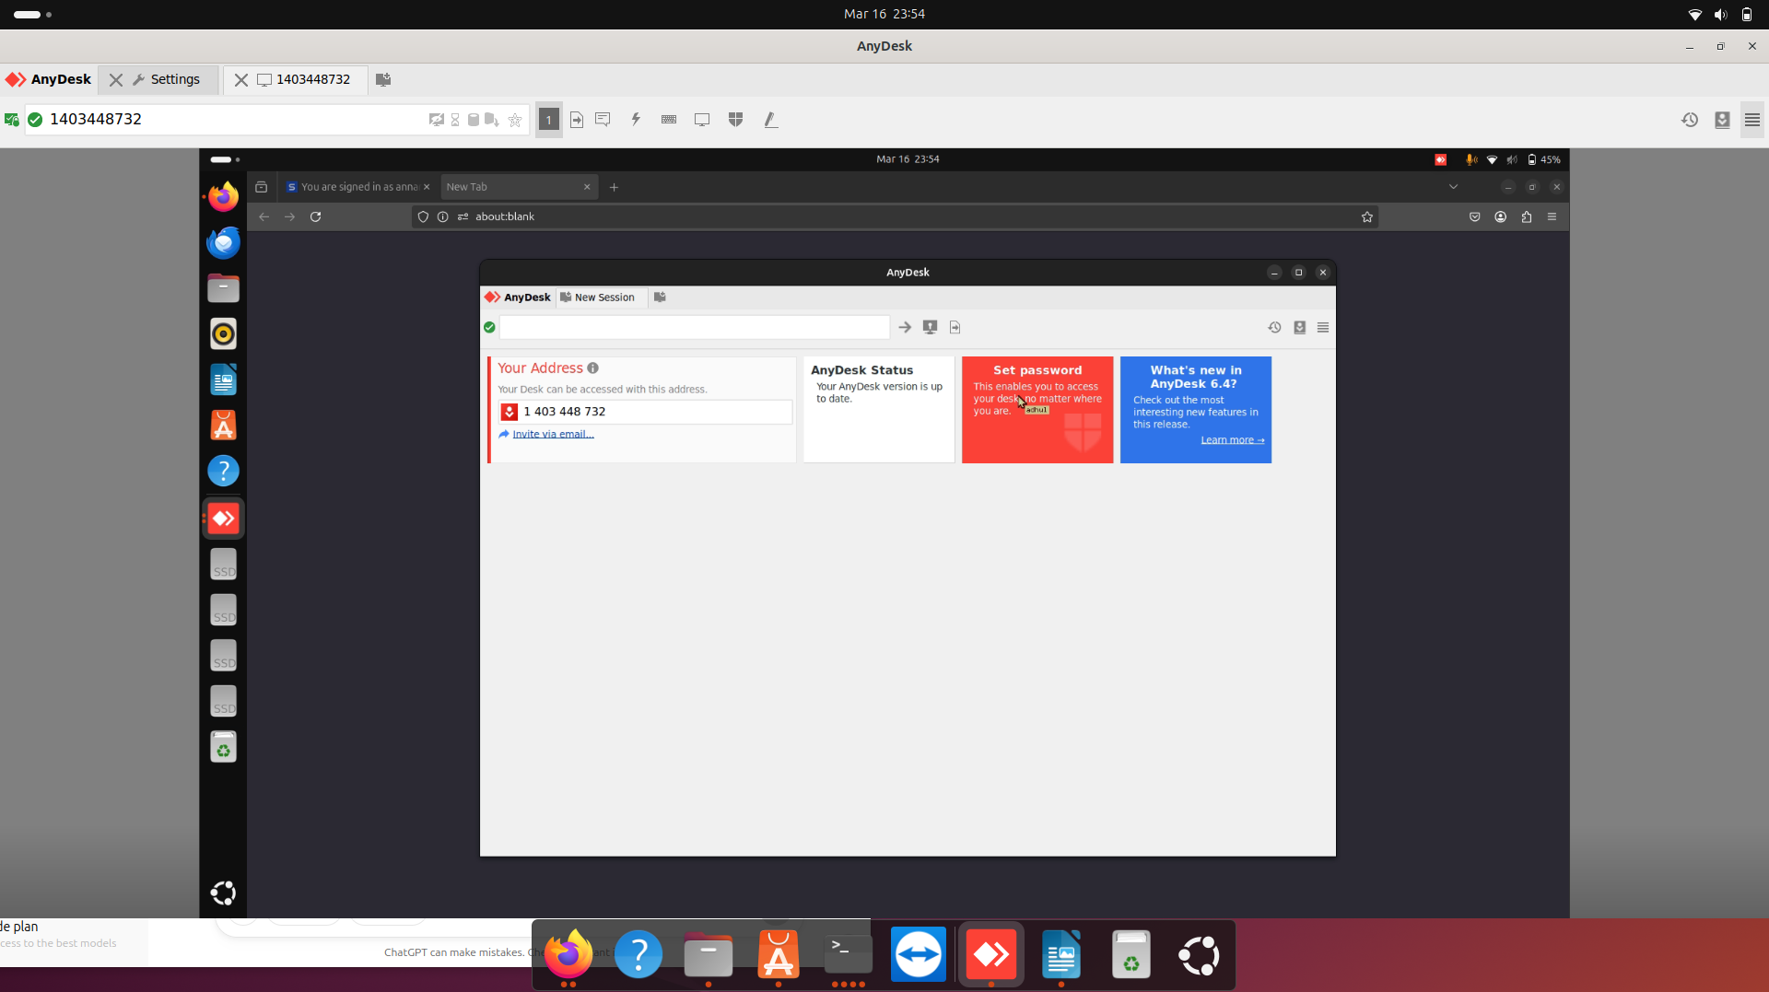
DEMONSTRATION :

TEAMVIEWER

INTRODUCTION:
- Teamviewer is the user friendly remote access application which runs on its own proprietary protocol that makes it more secure.
- It requires to download the teamviewer software on the client side and quick support or teamviewer software on the partner (server) side .
- From the partner’s credentials (will be shown once teamviewer is installed) , client machine can get remote access.
- It doesn’t need any port forwarding as required in VNC applications since it runs on its own proprietary protocol.

DEMONSTRATION :

